**Python Project**



Fig 1: Importing libraries

Source: Self-created with Jupyter notebook



Fig 2: Importing data

Source: Self-created with Jupyter notebook

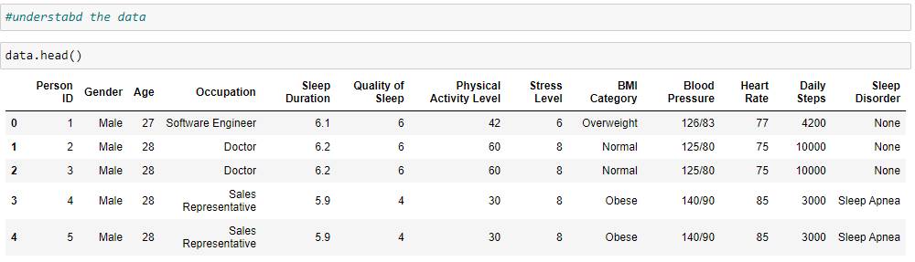

Fig 3: Data head

Source: Self-created with Jupyter notebook

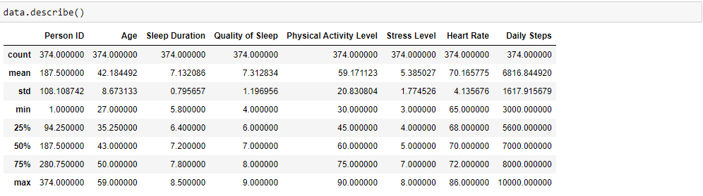

Fig 4: Describing data

Source: Self-created with Jupyter notebook

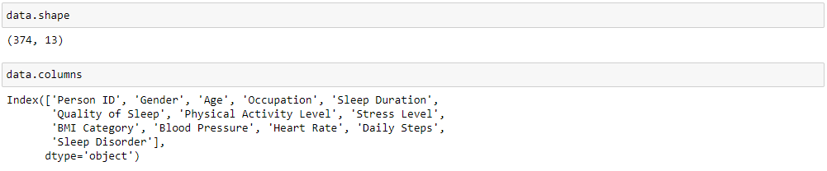

Fig 5: Shape of data

Source: Self-created with Jupyter notebook

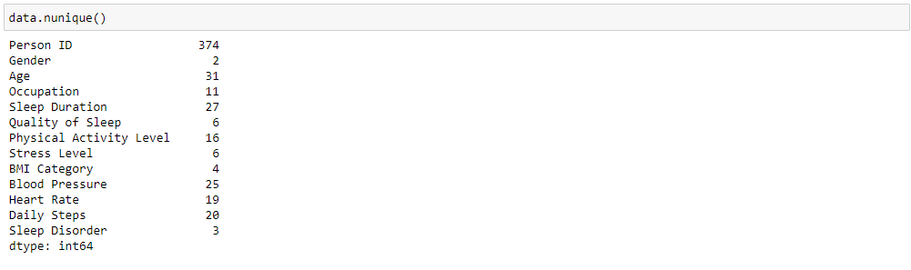

Fig 6: Checking unique values in each data column

Source: Self-created with Jupyter notebook

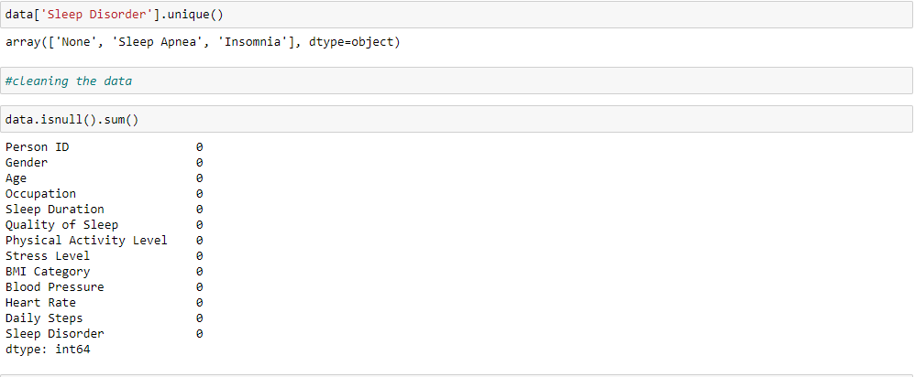

Fig 7: Showing Unique values of sleep disorder column

Source: Self-created with Jupyter notebook

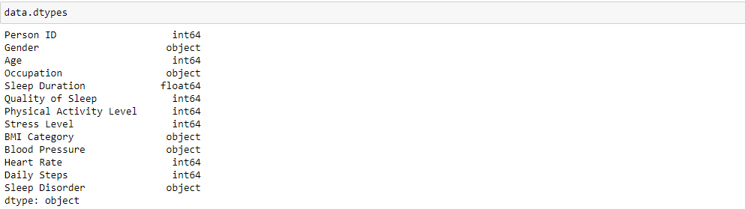

Fig 8: Checking data values in each column

Source: Self-created with Jupyter notebook

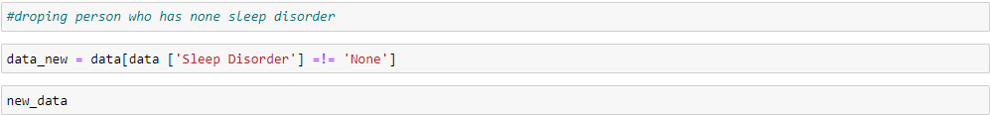

Fig 9: Dropping rows who has no sleep disorders

Source: Self-created with Jupyter notebook

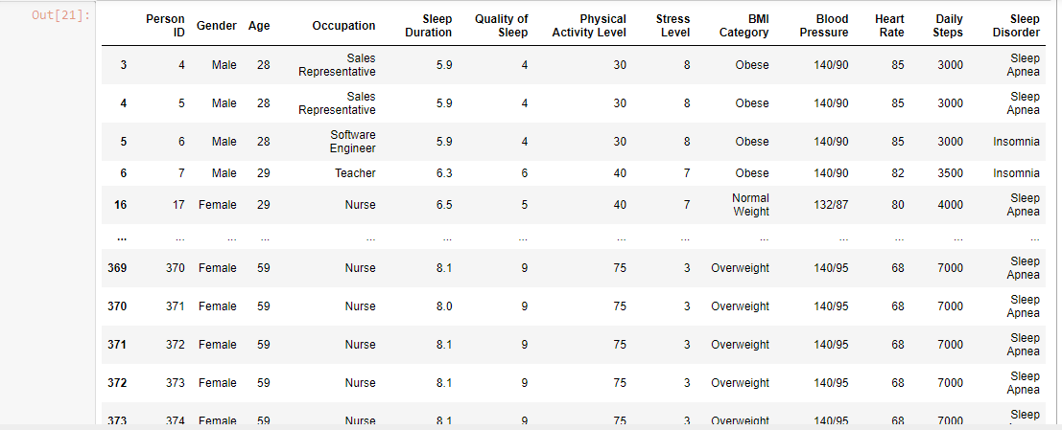

Fig 10: Output after dropping rows

Source: Self-created with Jupyter notebook

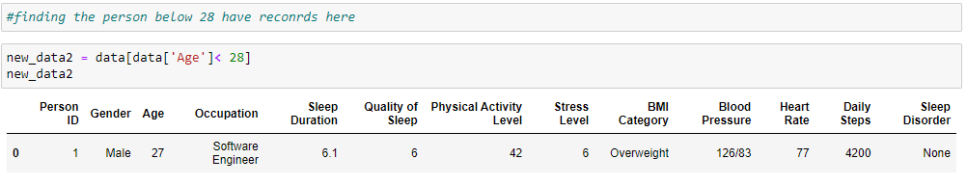

Fig 11: Finding records below age 28

Source: Self-created with Jupyter notebook

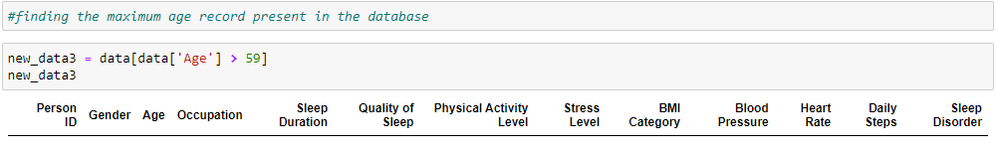

Fig 12: Finding records above age 59

Source: Self-created with Jupyter notebook

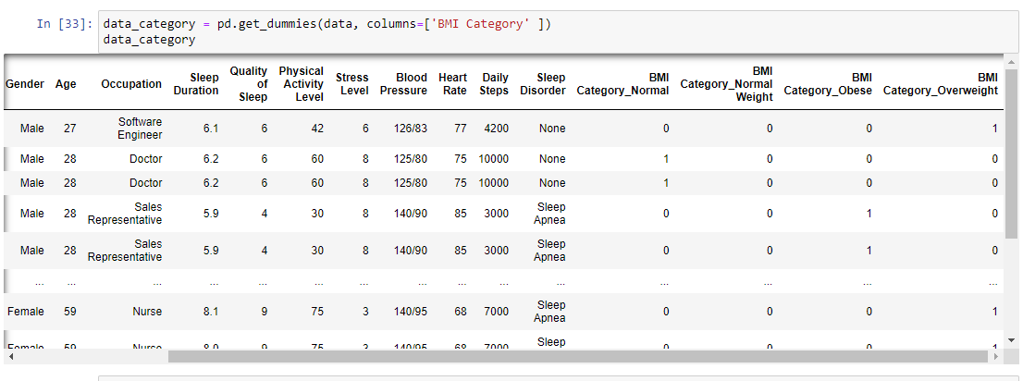

Fig 13: Creating dummies for BMI category

Source: Self-created with Jupyter notebook

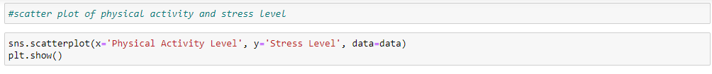

Fig 14: Creating scatter plot for finding relation among physical activity level and stress level

Source: Self-created with Jupyter notebook

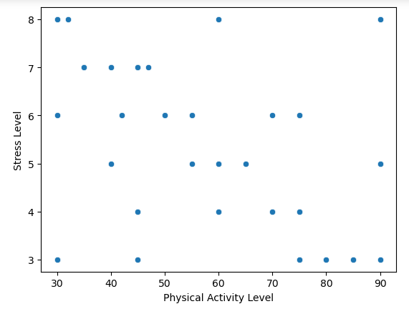

Fig 15: Output of Scatter plot

Source: Self-created with Jupyter notebook